Task 1: Distributed Schema
-----------------------------------------------------------------------
Description & Key Deliverables: Split your database into two logical nodes (e.g.,
BranchDB_A, BranchDB_B) using horizontal or vertical fragmentation. Submit an ER diagram and SQL scripts that create both schemas.
The existing Health Insuarence database is which currently has a central "InsuranceCompany" table and multiple dependent tables like: Plans, PolicyHolder, Hospital, Service, Claim, Assessor and Payment. If I classify insurance companies as Public or Private, I can horizontally partition all dependent table’s data by that category —meaning: 1) Node A (Public node): as the database that keeps all data related to public or government insurance companies.

Task 3: Parallel Query Execution
-------------------------------------------------
In PostgreSQL setting hints to force parallel or serial query execution, installation and enabling pg_hint_plan because PostgreSQL ignores hint by default.
CREATE EXTENSION pg_hint_plan; /* script to enable hint */
SELECT * FROM pg_available_extensions WHERE name = 'pg_hint_plan'; /* checking available hint extension */
SET max_parallel_workers_per_gather = 8; /* setting up to 8 parallel worker processes allowed to use when executing parallel queries */

SELECT COUNT(*) FROM claim;
--the table claim has fear data (9), yet to compare this we need a large table
--Let's create a large table called large_claims that has 1000000 and then run the query.
-- Create a large table by duplicating the claim table many times

CREATE TABLE large_claims AS
SELECT
(random()*1000000)::int as claimid,
(array['A00000001','B00000002','C00000003','D00000004','E00000005','F00000006','G00000007','H00000008','I00000009','J00000010'])[(random()*10)::int] as holderid,
(random()*8+1)::int as hospitalid,
current_date - (random()*365)::int as datefiled,
(random()*100000)::numeric(12,2) as amountclaimed,
(array['Pending','Approved','Rejected'])[(random()*3)::int] as status
FROM generate_series(1, 1000000);

SELECT COUNT(*) FROM large_claims;

-- Check the current setting of max_parallel_workers_per_gather
SHOW max_parallel_workers_per_gather;

-- our max_parallel_workers_per_gather is Set to 8 as done above for the session.
--(SET max_parallel_workers_per_gather = 8;)

Now, run a parallel and serial query and make comparison
1. Serial execution
-- Serial execution without (formated result)
EXPLAIN ANALYZE
SELECT status, COUNT(*), AVG(amountclaimed)
FROM large_claims
GROUP BY status;
Output:
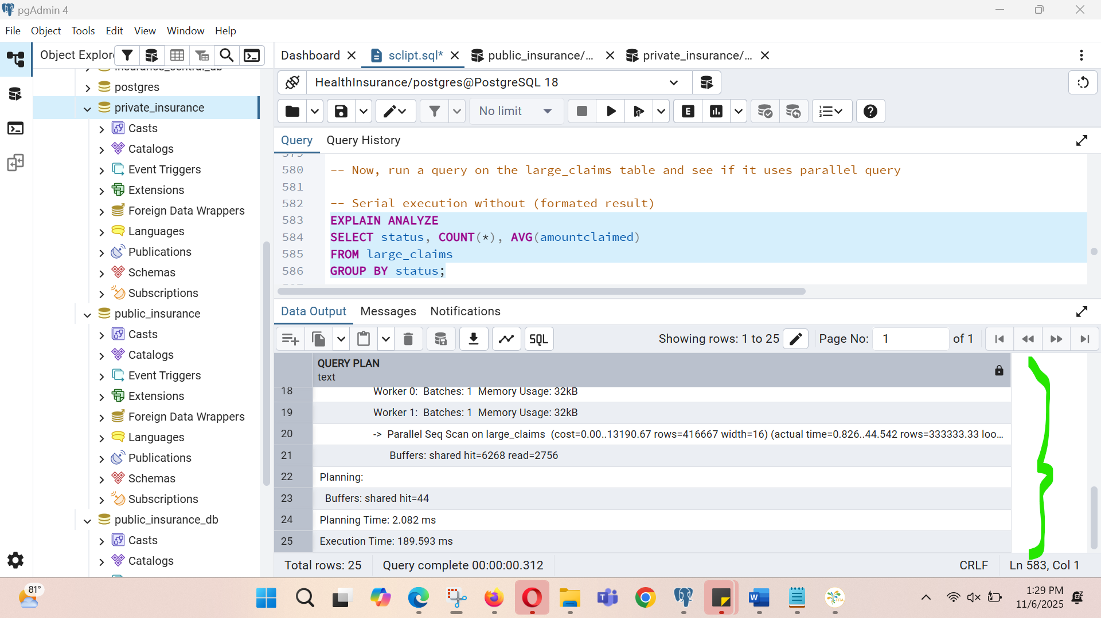

-- Serial execution with (formatted result)
EXPLAIN (ANALYZE, FORMAT JSON)
SELECT status, COUNT(*), AVG(amountclaimed)
FROM large_claims
GROUP BY status;

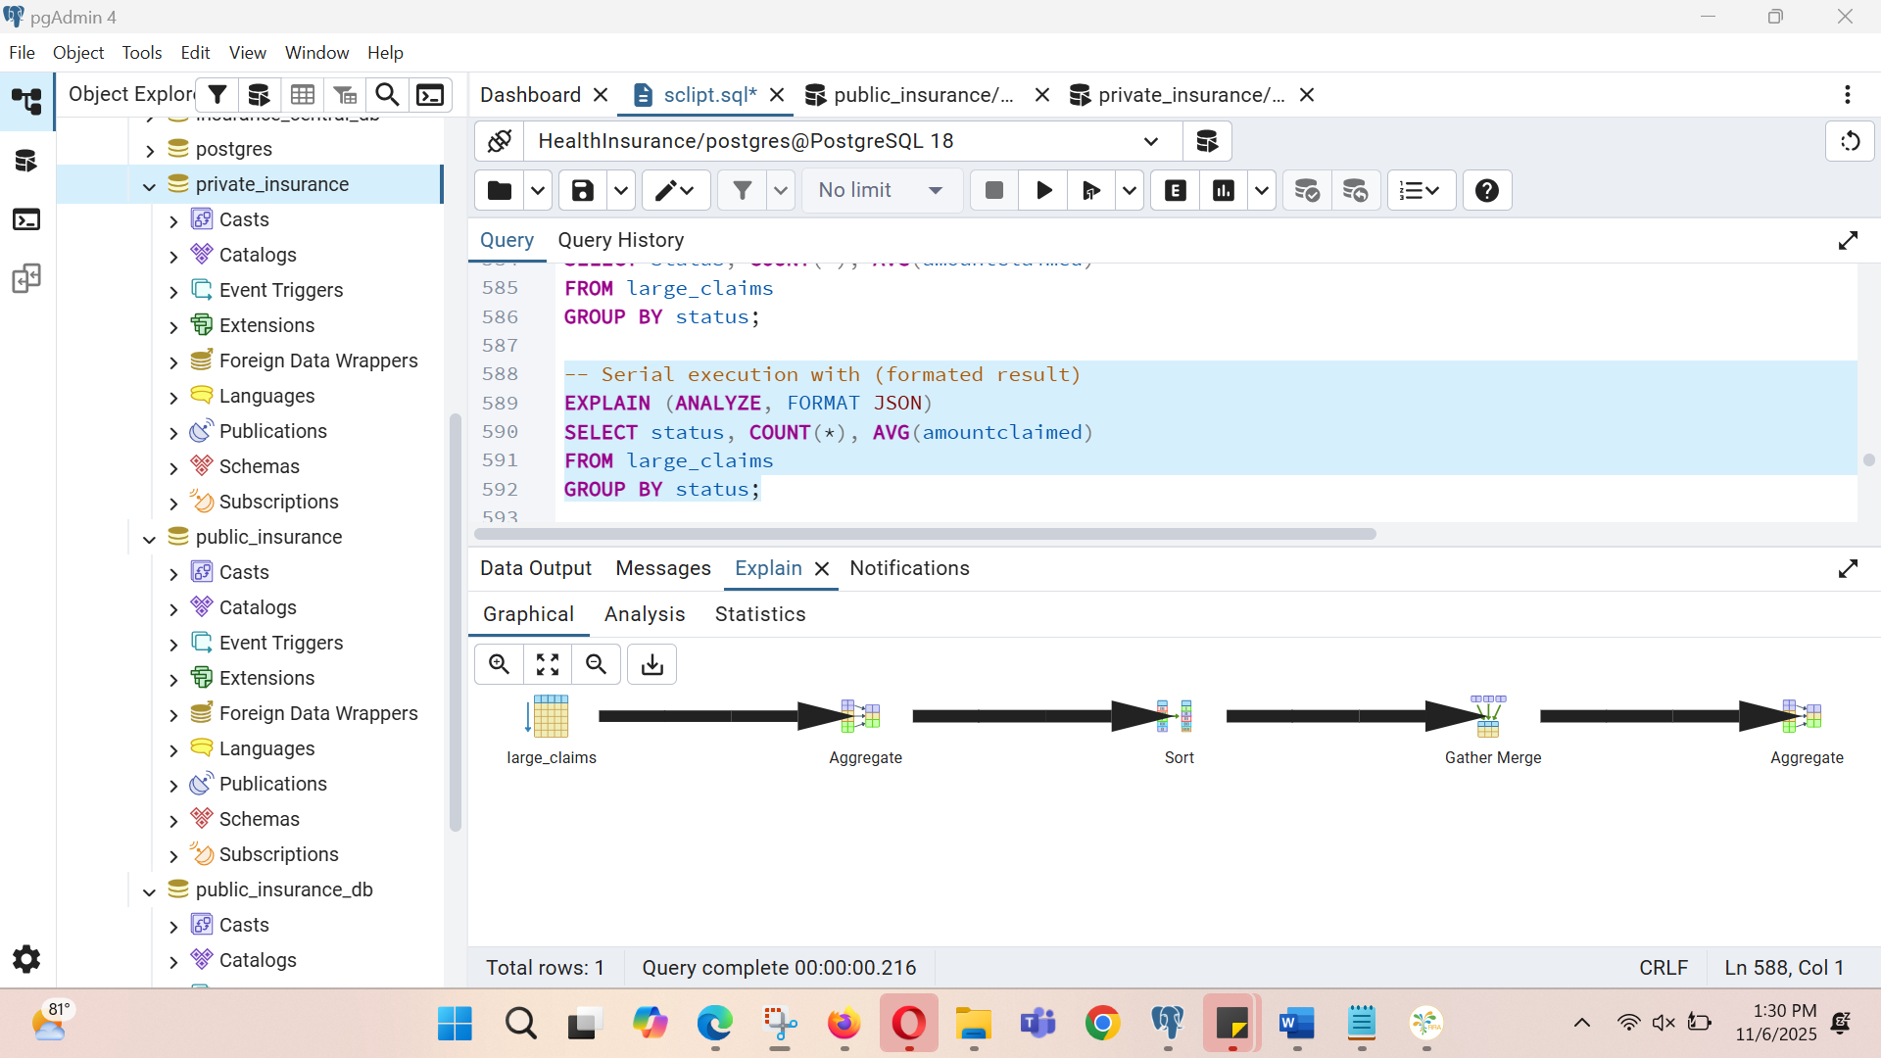

2. Parallel execution
--Parallel execution without (formated result)
EXPLAIN ANALYZE
SELECT status, /*+ Parallel(PolicyHolder 4) */ COUNT(*), AVG(amountclaimed)
FROM large_claims
GROUP BY status;

Output:
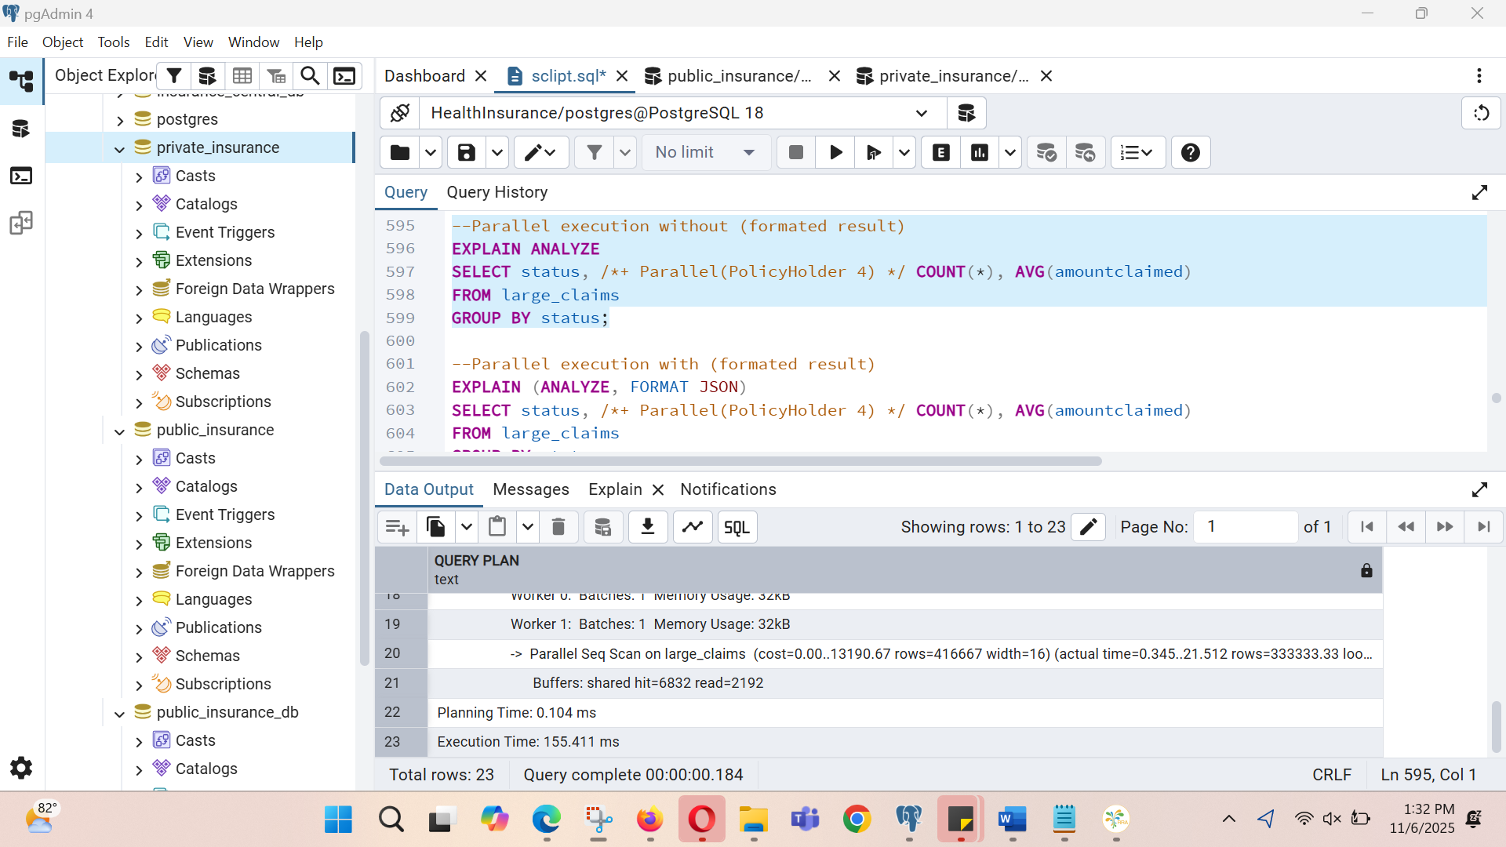

--Parallel execution with (formated result)
EXPLAIN (ANALYZE, FORMAT JSON)
SELECT status, /*+ Parallel(PolicyHolder 4) */ COUNT(*), AVG(amountclaimed)
FROM large_claims
GROUP BY status;

